<Partner Name>
<Partner Product>

RSA Ready Implementation Guide for


Radware
AppWall 5.6



Solution Summary

The integration of the AppWall Web Application Firewall with RSA NetWitness provides centralized log management and events correlation from different AppWall devices and other systems which becomes a critical part of the organization’s IT security program. Customers can generate reports, monitor and audit user activity, conduct historical forensics and apply trend analysis.
RSA NetWitness Features
Appwall 5.6
radwarepe.envision
radwarepe
Web Application Security
Syslog
Integration package name
Device display name within NetWitness
Event source class Collection method

RSA NetWitness Community

The RSA NetWitness Community is an online forum for customers and partners to exchange technical information and best practices with each other. The forum also contains the location to download the NetWitness Integration Package for this guide. All NetWitness customers and partners are invited to register and participate in the RSA NetWitness Community.
Once you have downloaded the NetWitness Integration Package, the next steps are to deploy this on all log decoders. For steps to disable or remove the NetWitness Integration Package, please refer to the Appendix of this Guide.

The RSA NetWitness package consists of the following files:
Filename | File Function
radwarepe.envision | NetWitness package deployed to parse events from device integrations.
radwarepemsg.xml | A copy of the device xml contained within the NetWitness package.
table-map-custom.xml | Enables NetWitness variables disabled by default.

Release Notes

Release Date | What’s New In This Release
12/02/2013 | Initial support for Radware AppWall.
3/1/2016 | RSA NetWitness 10.5 Support.

RSA NetWitness Configuration

Download the RSA enVision Configuration File
The enVision configuration file contains:
    - table-map.xml is the RSA enVision variable to NetWitness meta key map.
    - ipaddr.tab is the configuration file for DIRCHK log parser function.
    - ecat.ini is the legacy event category ID to user friendly event category name map.

To deploy the enVision configuration file from live:

- Browse Live for the Event Source Log Parsers that you need using RSA Log Device as the Resource Type. The Event Source Log Parsers available for adding and updating are displayed.
- Select the enVision configuration file that you want to deploy.
- In the Live Matching Resources toolbar, click Package > Create.
A ZIP archive will be created and downloaded to your default local directory. You can deploy the resources in the zip archive whenever you are ready, by selecting Deploy from the menu, and following the steps in the Deployment Wizard. For more details, see Deploy Resources Manually in the Live Services Management Guide.

Deploy the NetWitness Integration Package
After completing the previous section, Deploy the enVision Config File, you can now deploy the NetWitness Integration Package. Download the appropriate RSA Partner Integration Package, then log into NetWitness to perform the following actions:
- Depending on your version:
    - For NetWitness 11.x: Go to ADMIN > Services.
    - For NetWitness 10.x: Go to NetWitness > Administration > Services.

  - Select a Log Decoder service and go to View > Config.

  - Select the Parsers tab.

  - Click on Upload. The Upload Parser dialog is displayed. In the Upload Parser dialog, you can review the existing Event Source Log Parsers on the Log Decoder.

  - Click on the + (Add Button), go to the folder on your local network, and select the Event Source Log Parser file. You see the selected Event Source Log Parsers from the file under File Name in the Upload Parsers dialog box.

  - Click on Upload. The Event Source Log Parsers are uploaded to the Log Decoder overwriting any earlier versions of these parsers.

Enable a Log Parser
To enable an event source parser, or to ensure that it is already enabled:
- Depending on your version:

- For NetWitness 11.x: Go to ADMIN > Services.
- For NetWitness 10.x: Go to NetWitness > Administration > Services.

- In the Services grid, select a Log Decoder, and from the Actions menu, choose View > Config.

- In the Service Parsers Configuration panel, search for your event source.

- Ensure that you select the Config Value box for your parser. Select Enable All to enable all of your event source parsers.

- Click Apply. When you click Apply, note that all parsers are reloaded into RSA NetWitness.

Partner Product Configuration

Before You Begin
This section provides instructions for configuring the Radware AppWall with RSA NetWitness. This document is not intended to suggest optimum installations or configurations.
It is assumed that the reader has both working knowledge of all products involved, and the ability to perform the tasks outlined in this section. Administrators should have access to the product documentation for all products in order to install the required components.
All Radware AppWall components must be installed and working prior to the integration. Perform the necessary tests to confirm that this is true before proceeding.

Important: The configuration shown in this Implementation Guide is for example and testing purposes only. It is not intended to be the optimal setup for the device. It is recommended that customers make sure Radware Appwall is properly configured and secured before deploying to a production environment. For more information, please refer to the Radware Appwall documentation or website.

AppWall Configuration
- Login to the AppWall device.
- In the Configuration view navigate to Services > Publisher > Recipients.
- Select the Syslog tab and check Enable.
- Under the Destination table click the Add button and enter the RSA NetWitness IP address and port.
- Select the maximum syslog message size to be sent (1024, 2048 or 4096) and the specific field sizes.
- Click the Test Settings button to send a sample syslog message to validate proper configuration.
- In the toolbar, click Save and Apply.
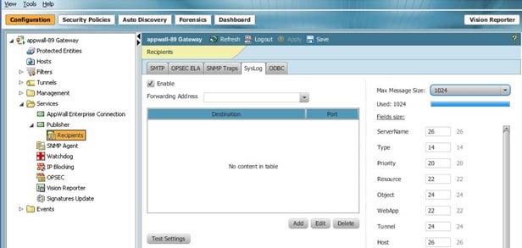

- Configure the types of events you would like to send (Security, System or Administration) navigating to Events > Security Event Logs and select the Publishing Rules tab.

- Add a new publishing rule defining the specific severity level of events or the specific web application.
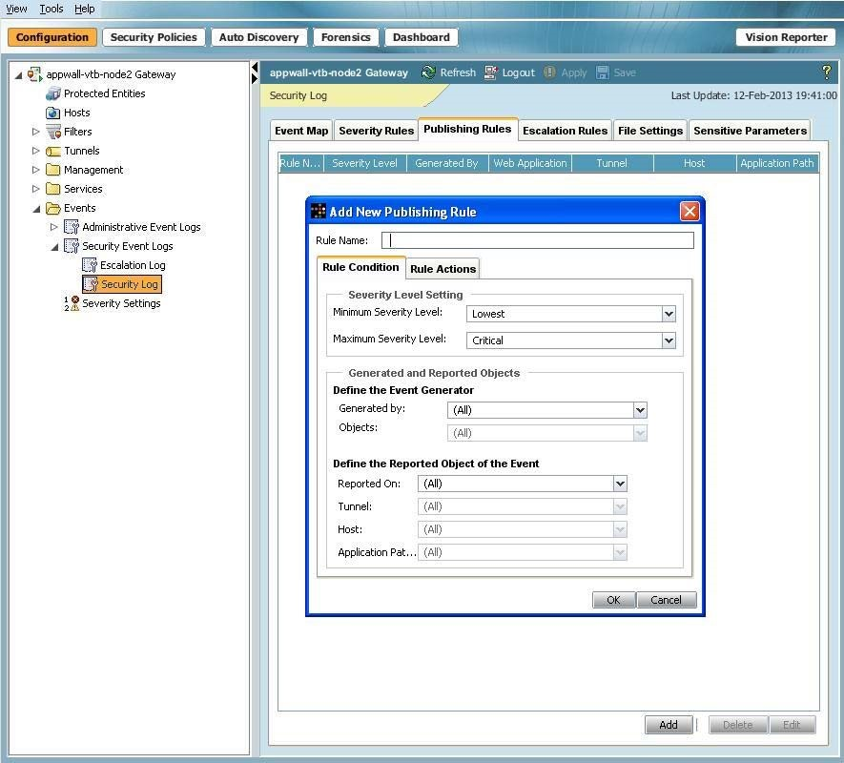

- Under the Rule Actions tab check the Send a syslog Notification checkbox and click OK.
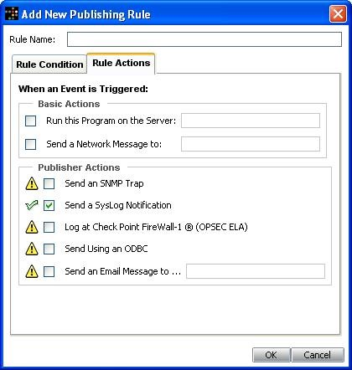

Certification Checklist for RSA NetWitness

Date Tested: March 1, 2016
Certificate Environment
Product Name | Version Information Operating System
RSA NetWitness | 10.5 | Virtual Appliance
Radware AppWall | 5.6 | Physical or Virtual Appliance

RSA NetWitness Test Case |  |  | Result
Device Administration
Partner’s device name appears in Device Parsers Configuration
Device can be enabled from Device Parsers Configuration
Device can be disabled from Device Parsers Configuration
Device can be removed from Device Parsers Configuration

Investigation
Device name displays properly from Device Type
Displays Meta Data properly within Investigator

= Pass = Fail N/A = Non-Available Function

Appendix

NetWitness Disable Device Parser
To disable the NetWitness Integration Package but not delete the XML from the system, perform the following:
- Navigate to Administration > Services, check the Log Decoder(s) and click View> Config.
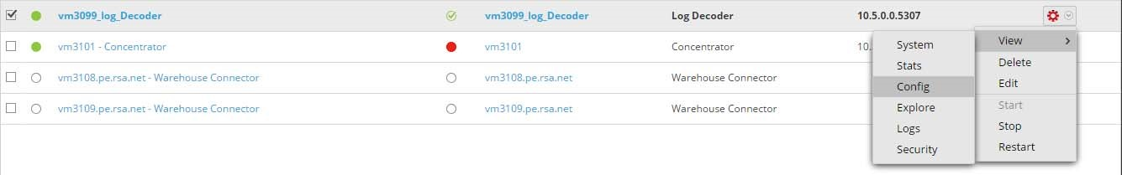

- From the Service Parses Configuration window, scroll down to the device you wish to disable and uncheck the Config Value checkbox.
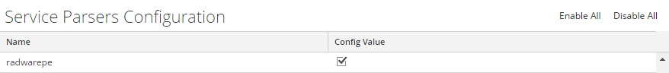
- Click Apply to save settings.

RSA NetWitness Remove Device Parser
To remove the NetWitness Integration Package files from the environment, perform the following:
- Connect to the NetWitness Log Decoder/Collector Server using SSH and open the /etc/netwitness/ng/envision/etc/devices folder.
- Search for the device you are targeting for removal and delete the folder containing the device xml.
- Returning the system to its original state will require either modifying or removing the tablemap-custom.xml based on your systems configuration. The table-map-custom.xml file is located in the /etc/netwitness/ng/envision/etc folder of the NetWitness Log Decoder(s).

